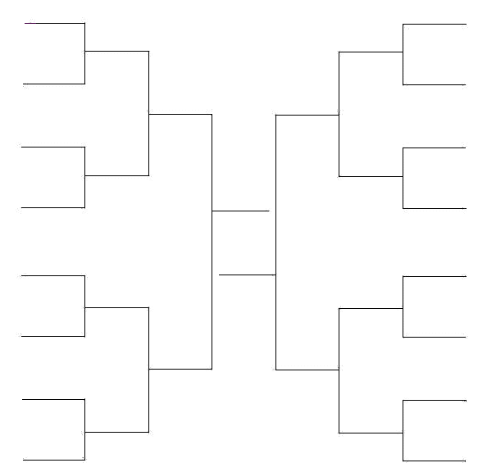

John Smith

John Smith

Thomas Paine

Thomas Paine

Meriwether Lewis

Thomas Jefferson

Benjamin Franklin

King George

Meriwether Lewis VS.

Ben Franklin

George Washington

George Washington

Thomas Jefferson

Samuel Adams

(Elimination Bracket)

William Clark

Francis Scott Key

Francis Scott Key

Dorothea Dix

Dorothea Dix

William Clark

Elizabeth Cady Stanton

Elizabeth Cady Stanton

Samuel Adams

King George